EC2 Tasks

1.Lauch one EC2 using Amazon Linux 2 image and add a script in user data to install Apache.
Launched an EC2 instance using amazon Linux image by adding script of httpd in the user data.
After that connected to server using ssh and checked the status of httpd.
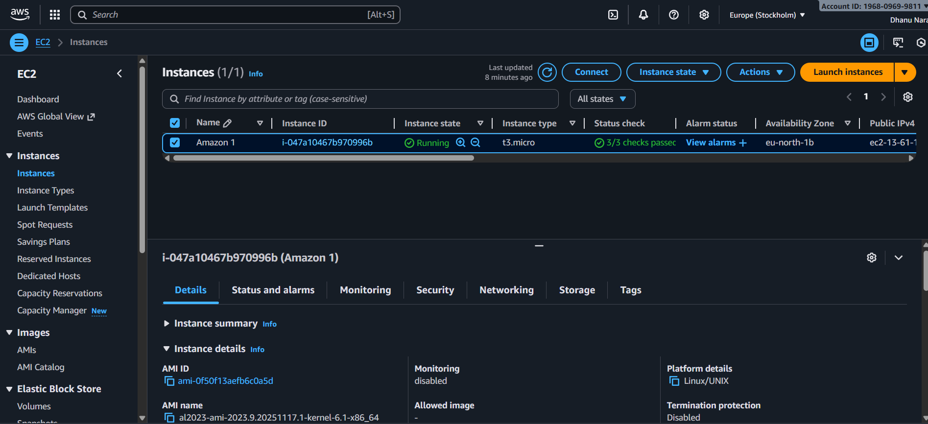
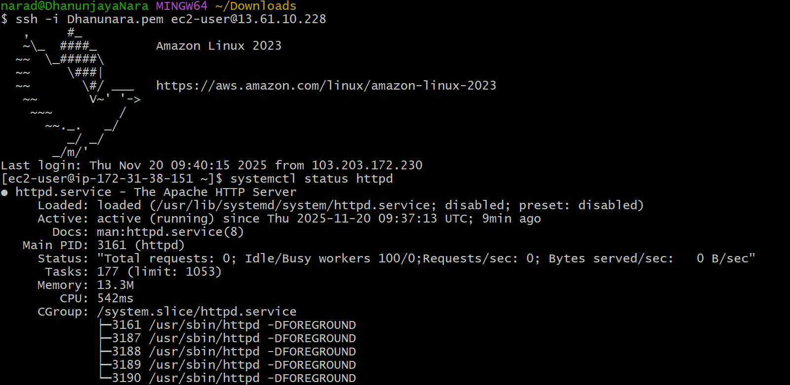

2.Launch one EC2 using Ubuntu image and add a script in user data to install nginx.
Launched an EC2 using Ubuntu image by adding a script of installing nginx.
And connected to the server and checked the status of nginx.
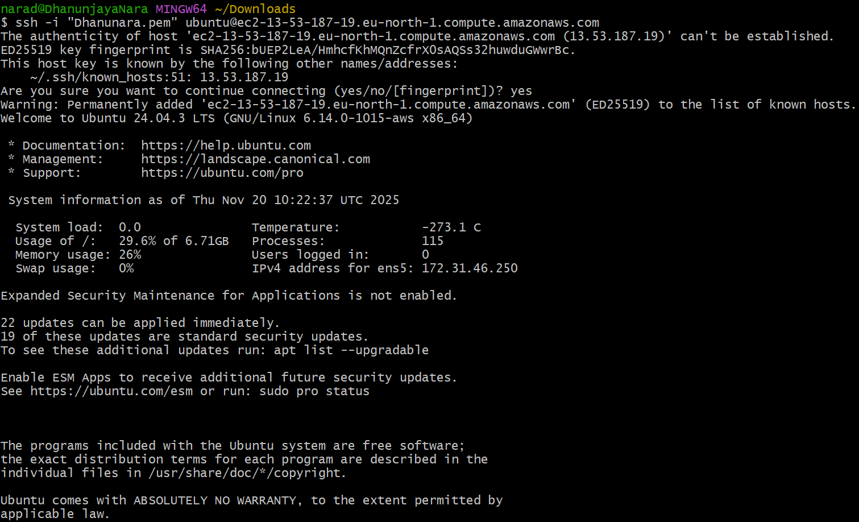
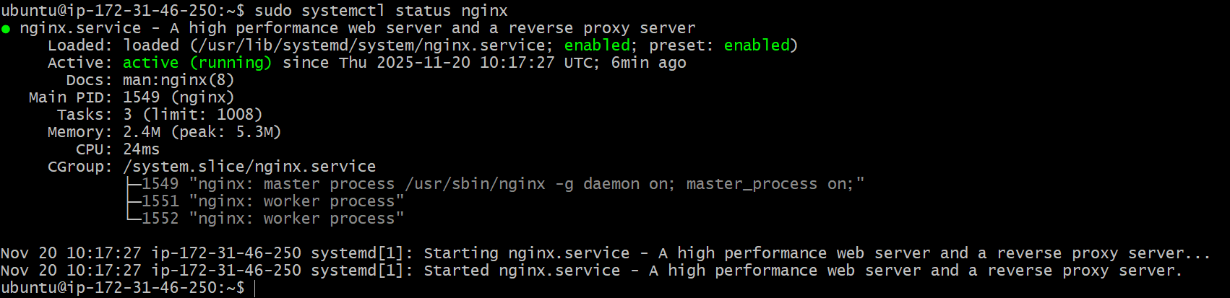

3.Launch one windows server and install Tomcat on windows.

First launched an instance using windows Amazon machine image.
Complete the ec2 instance launch first.
Then connect to windows server through RDP and after that we need to install tomcat manually in windows.
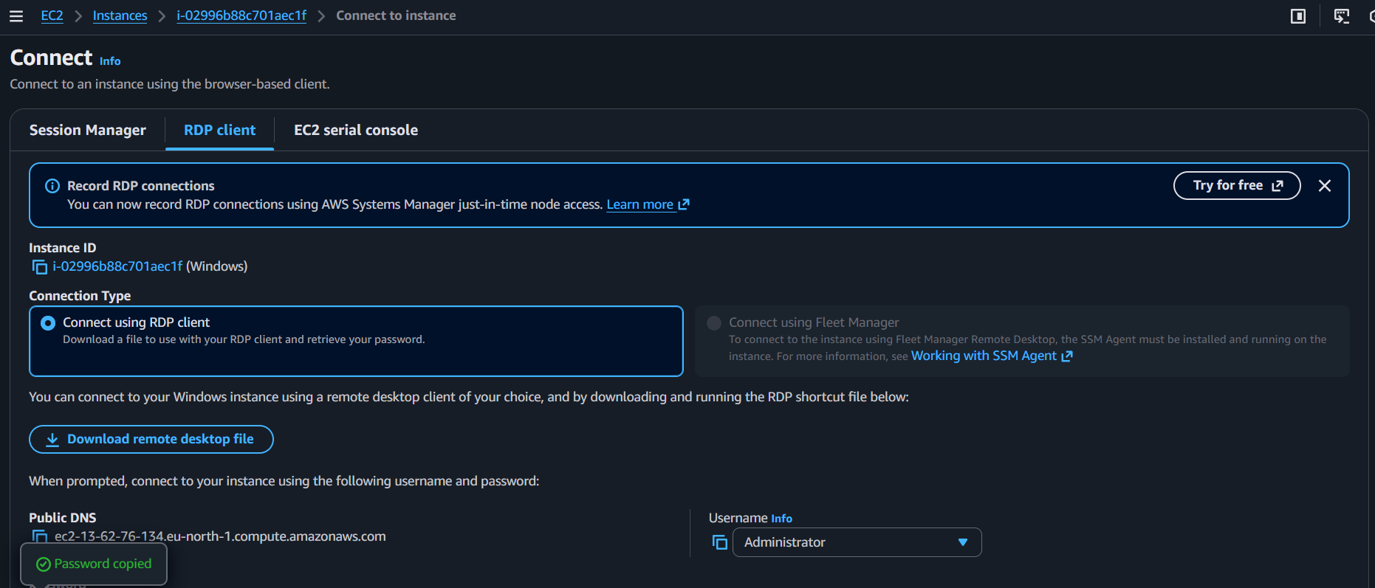
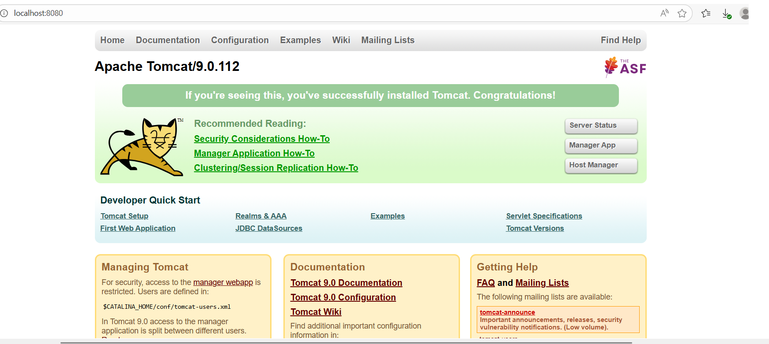

4.Take a snapshot of the instance created in task 1.
First we should open the EC2 instance created in the 1st task .
Snapshot is used to get back terminated instance . It is like back up for that terminated one we can retrive that through other instance.
After going into EC2 instance select the created instance and if we go down we will find storage and if we click that storage we will find volume.
After going volume we will find actions over there and in that snapsh0t will be available.
After adding description for your snapshot you can click create snapshot.
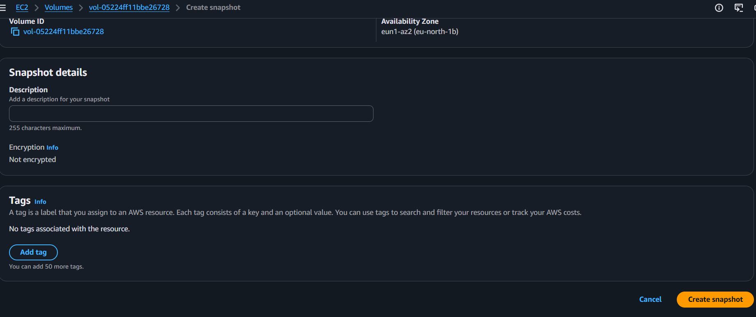

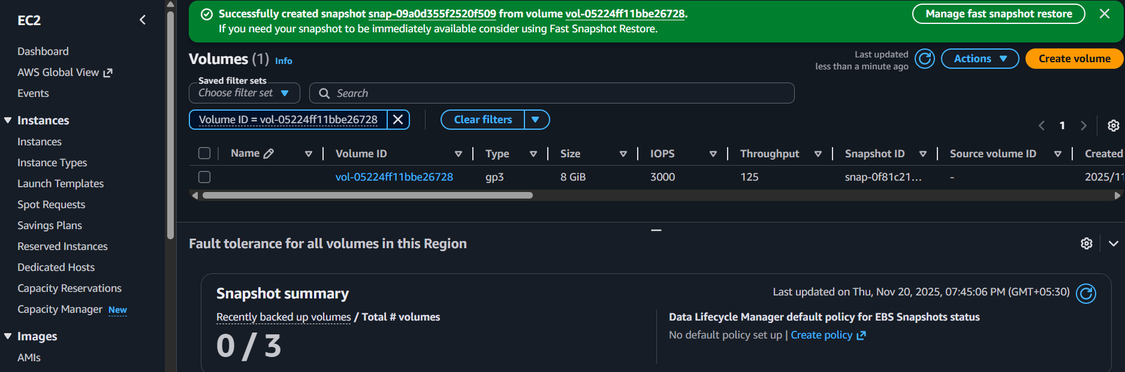

8.Launch one EC2 using AWS CLI.

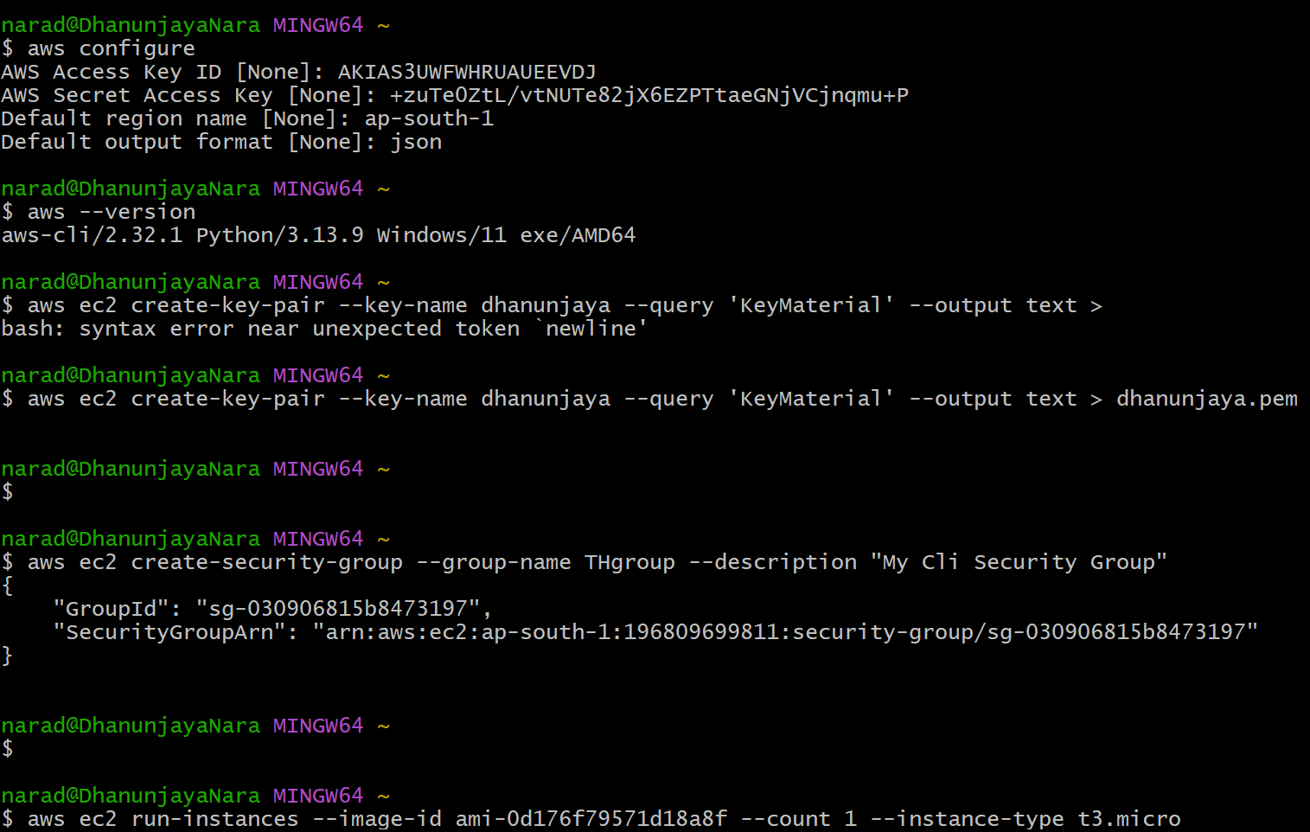
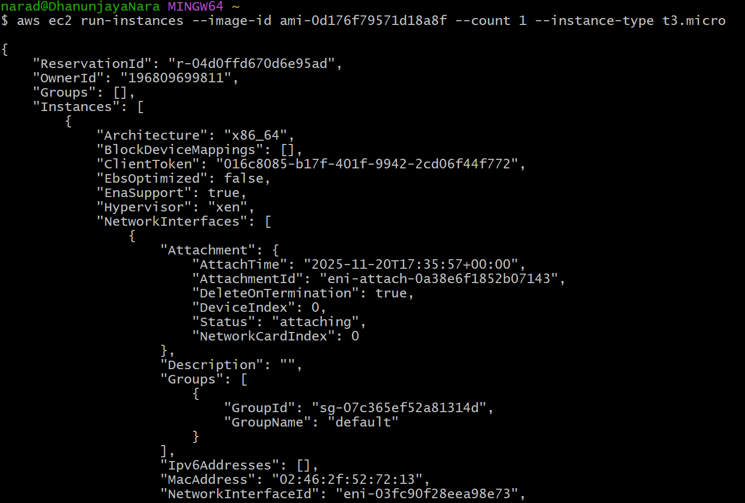

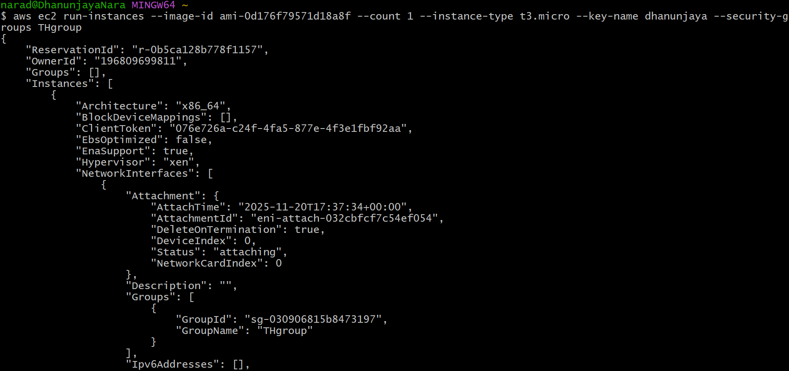
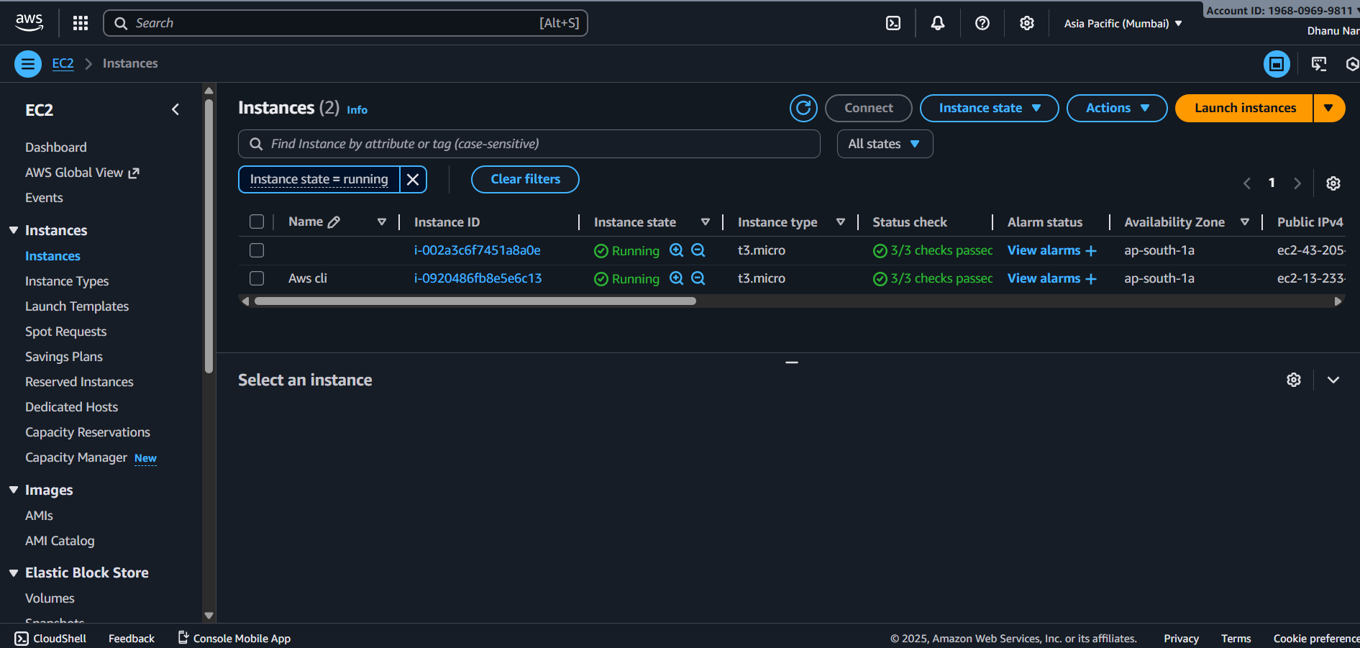

6.Launch any EC2 using the spot purchasing option.
Spot purchasing is an option where we can rent the EC2 server for lower price.
In this we will rent the server through bidding whoever bids the best price they will get the instance but after that if any other person bids for higher amount the first one will loose the access to the instance which is a major drawback in this.
While launching instance after selecting AMI , keypair , and security we will find advanced there we will find spot purchasing option and we can bid there .
After that then launch instance.
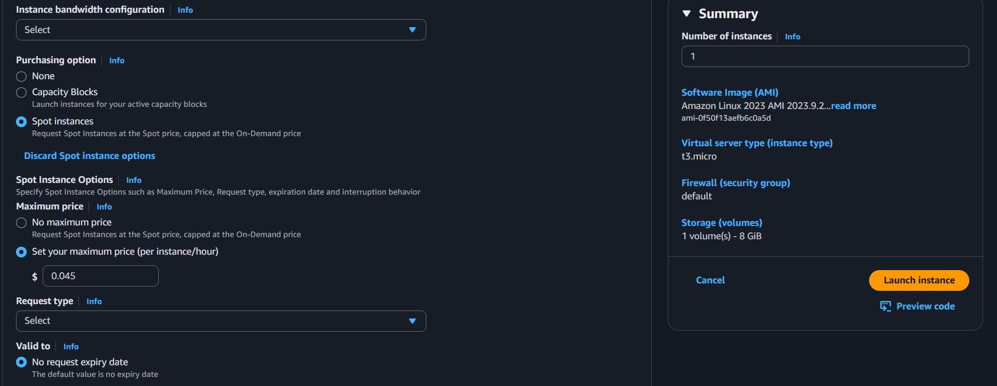
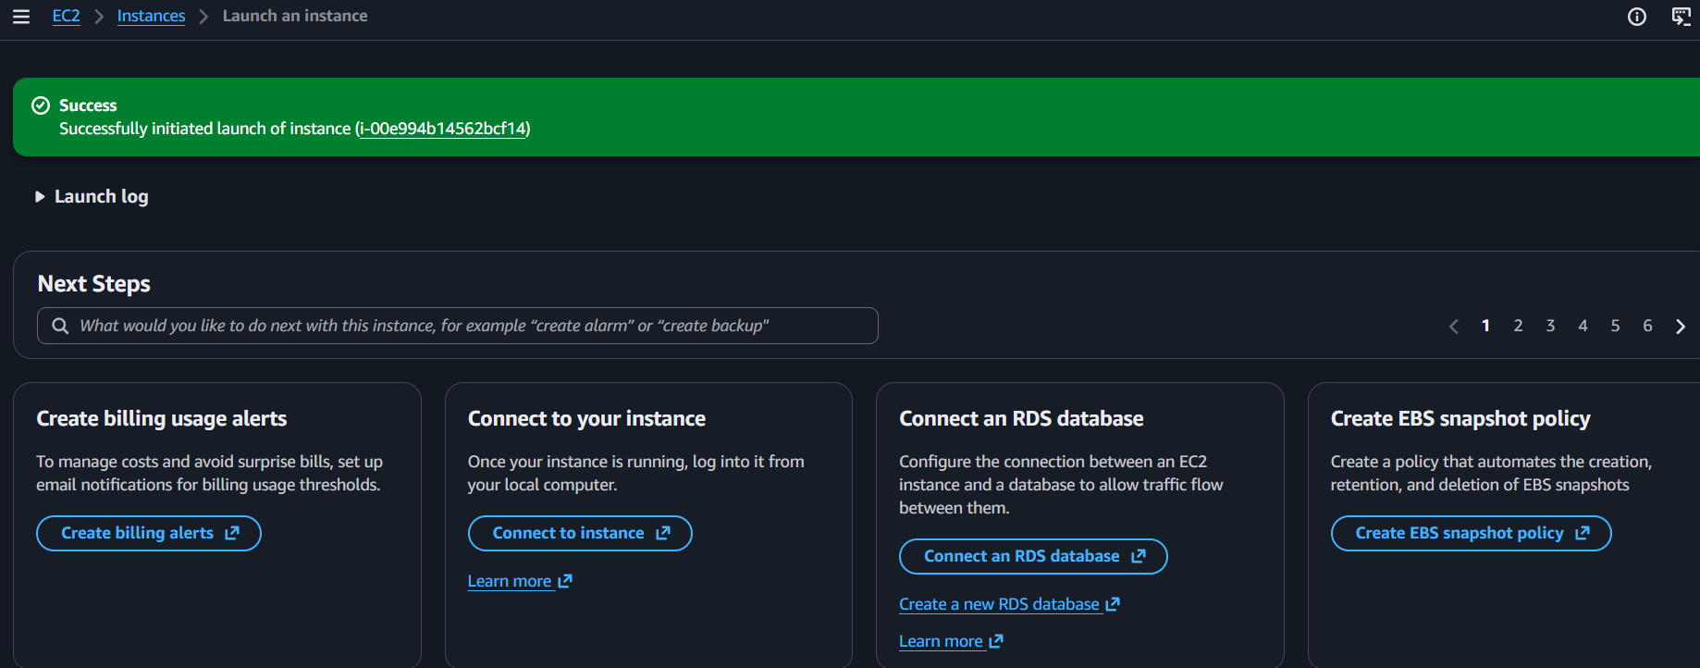

7.Enable termination policy on the EC2 created in Task 2.
If we go to actions there we will find instance settings and in that we will find change termination protection and if we click that it will show enable option.
After doing that in instance state even if we try to terminate and delete the instance it wont get delete since we enabled terminal protection.
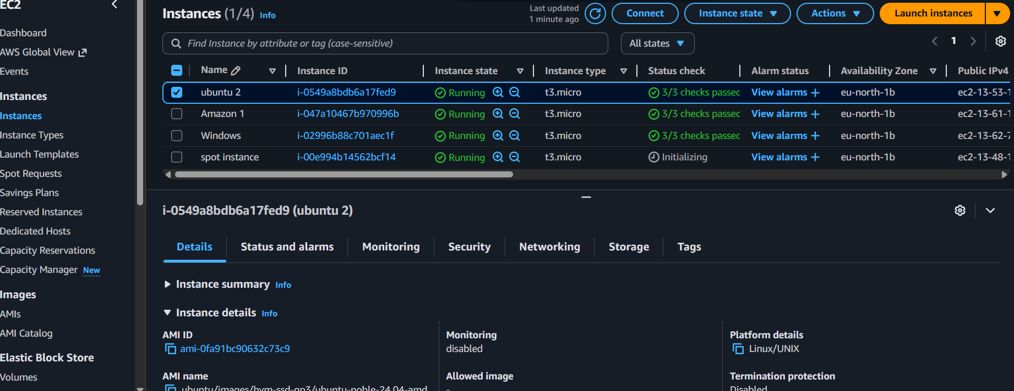
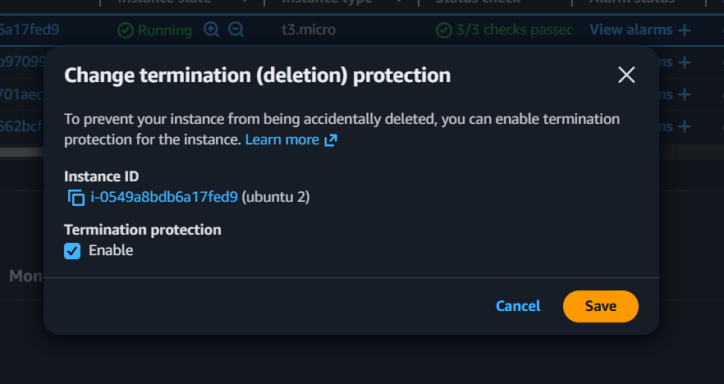
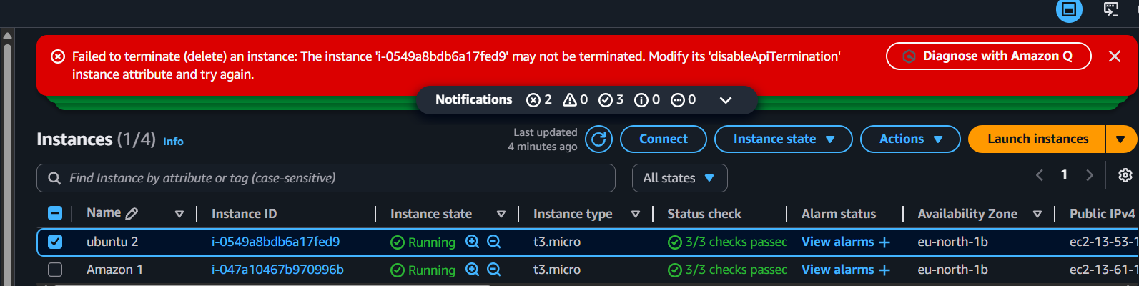

5.Assign paaswordless authentication for the EC2 created in task 2.
First in local machine we need to create ssh keys using command ssh-keygen
This command will create two keys in the windows home directory in .ssh hidden folder
After going to that folder see the public key using cat command . And copy that key.
Now open the ubuntu instance launched in task 2 and go to .ssh/authorisedkeys file in the ubuntu user home folder.
Paste the public key on top of already existed ssh key.
Go to git bash terminal now we can open without any key.
